PHILOSOPHY, UNIT III: EPISTEMOLOGY NOTES
“Epistemology” Greek for “the study of understanding.”
-Broadly, it is the theory of KNOWLEDGE, which asks if and how we can achieve certainty
-Key Question: How can I be certain my PERCEPTIONS and BELIEFS reflect Reality?
* “Perceptions” Our sensory experience of the world: sights, smells, tastes, etc.
--I perceive a carved redwood chair, which feels smooth and smells fragrant.
--MAYBE YOU CAN’T TELL IT’S IMITATION PLASTIC! OR YOU FORGOT YOU TOOK DMT AND YOU’RE HALLUCINATING!!
* “Beliefs” The concepts we develop and trust in to explain and structure that experience
--This chair came from Ron Swanson’s own woodshop! It cost a lot, but it’s well-made.
--BUT WHAT IF IT’S A FAKE? DID YOU SEE HIM MAKE IT? WHAT IF RON SWANSON DOESN’T REALLY EXIST??
In short, how can we make certain our perceptions and beliefs are trustworthy guides to our Reality?
____________________________________________________________________________
There are four broad “schools of thought” on this topic that you need to know, starting with three ancient ones:
1. Rationalism: LOGIC NEVER LIES
We can never be certain of our perceptions. Instead, we should trust logically-reasoned beliefs (necessary validity).
PLATO – There is a higher World of True Being (Ideas/Forms) that, while invisible, can be rationally proven to exist.
(For singular, temporal things to exist, they must gain their Being from an eternal, universal “Form” that “grounds” them; for example, all imperfect, worldly triangles participate in the Form, just as all cats participate in Cat-Ness).
ST. THOMAS AQUINAS – Prime Mover argument claims to “prove” God’s logically-necessary existence.
(Everything in nature has a cause that comes before it – you came from your parents, who came from their parents, and so on… But there must be a FIRST cause that has NO prior cause that “caused” the Universe to Be: that is GOD.)
* Notice that both men are DUALISTS (believing in a higher “ideal” reality) that cannot be shown, only argued for.
2. Empiricism: SEEING IS BELIEVING
We can never “factor everything into” analysis. So we should always trust empirically-verifiable (observable) evidence.
ARISTOTLE – Plato is wrong; there is NO higher World. Truth resides in the world around us, waiting to be studied.
(Observation of phenomena Comparison Categorization: An early version of the Scientific Method!)
JOHN LOCKE – The Mind starts as a “blank slate” (tabula rasa). It is “filled in” through Experience Knowledge.
(We create Ideas or concepts by “reflecting” on our sensory “impressions” and making connections between them.)
3. Skepticism: YOU KNOW NOTHING
We can never be sure of our perceptions or beliefs (or both), to such an extent that “knowledge” is always questionable.
SOCRATES: Claims he “Knows Nothing” – This makes him wise, because he knows Absolute Truth is beyond our reach
DIOGENES: “A Socrates Gone Mad” - Engages in vulgarity, insults and theatrics to show that society’s customs are lies
SEXTUS EMPIRICUS: Roman ultra-skeptic – a troll before the internet, who would debate two opposing sides at once
These ancient Skeptics are less important than these two from the Renaissance/Enlightenment era’s birth of science:
I. RENE DESCARTES – Turns Rationalism into Skepticism by doubting ALL sensory evidence:
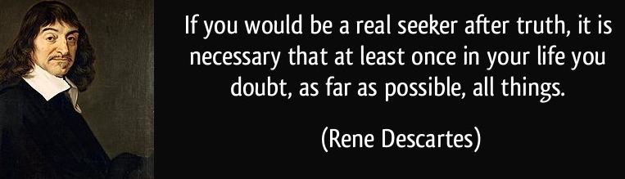
restores belief with the Cogito- “I am thinking, therefore I Exist,” meaning The Self is the first, and possibly only certainty available to Reason alone:
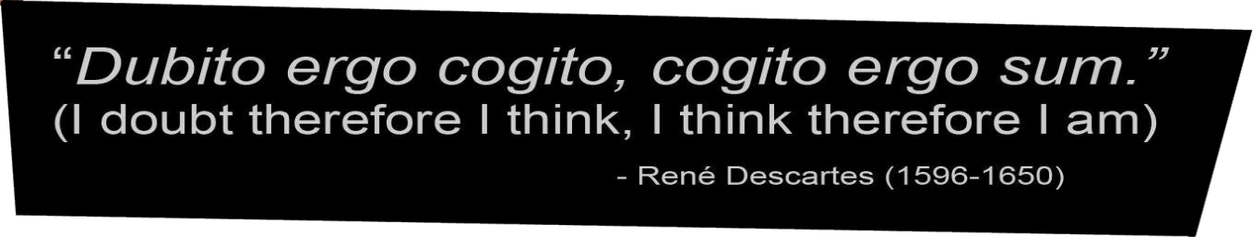
[But, Descartes also claimed he could logically justify the existence of God/World based on his proven existence: false!]
II. DAVID HUME – Turns Empiricism into Skepticism by doubting Reason’s power to understand the world around us.
“Knowledge” is really “Custom” or Habit – we get used to things happening certain ways and trust they’ll stay the same (e.g. the sun will rise tomorrow, like always), but there are always unknowns to prove us wrong (e.g. black swans). SO,
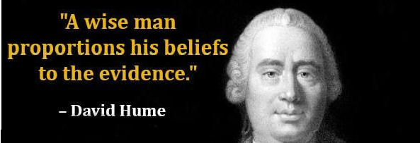
[Hume’s “problem of induction” – can we really base knowledge of the future on past experience? – remains alive today.]
