ETHICS: PLATO AND ARISTOTLE
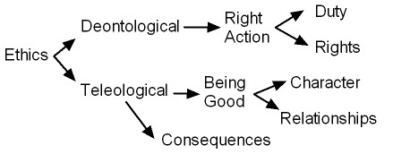
PLATO = Deontological: rights, duties, laws
(Deontological ethics is about following the rules.)
ARISTOTLE = Teleological: goodness, virtues, character
(Teleological ethics is about “actualizing” good potentials.)
________________________
PLATO’S ETHICS AND POLITICS: Hierarchical Ascent to Good
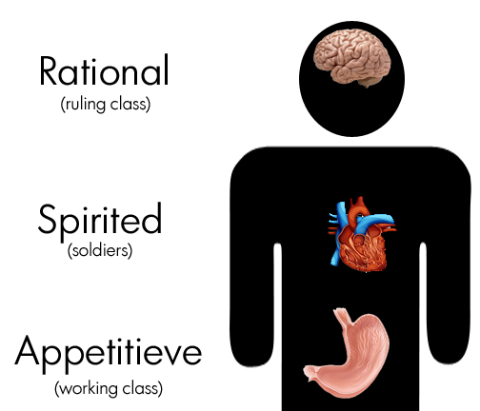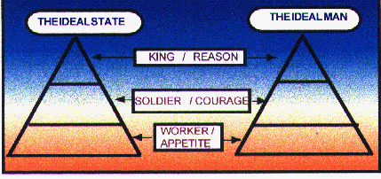
______________
SUMMARY:
Premise 1 (Epistemological): The body and its senses deceive us because they only show “becoming.”
Premise 2 (Ontological): There must exist a world of Higher Forms, of Being, which only our Soul/Mind can know!
CONCLUSION (Ethical): To be “good,” we must deny the things of this world and pursue knowledge of the Higher Forms.
And the “best” people (those who are closest to those Higher Forms, i.e. philosophers) should rule everyone else!
ARISTOTLE’S ETHICS AND POLITICS: Fulfilling Our Final Cause (Telos / Teleology)
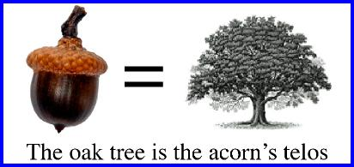
For Aristotle we are RATIONAL and POLITICAL animals.
The Good Life for us involves using our rational abilities as part of a community (Polis) in pursuit of Greatness.
This is a life of moderation and virtue, but it leads to the fulfilled happiness of human “flourishing” (Eudaimonia).
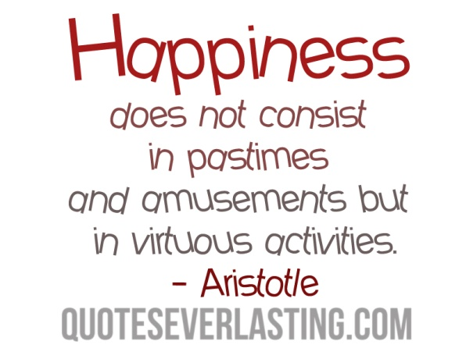
______________________________________________________________________________
SUMMARY:
Premise 1 (Epistemological): We can understand anything by examining it (4 causes).
Premise 2 (Ontological): Every type of thing is unique and has its own “purpose” common to that type.
(final cause = TELOS; TELEOLOGY = this belief that all things have inherent “purposes”_
CONCLUSION (Ethical): Since a “good” thing is one that does its “purpose” (final cause) well, a “good” person is one who does the human function well … And if you examine humans you see they are RATIONAL and POLITICAL animals.
So a “good” human life is one that is rational and lived in harmony with other rational beings, pursuing excellence.

