THE PHILOSOPHY OF SOCRATES
CORE ARGUMENT:
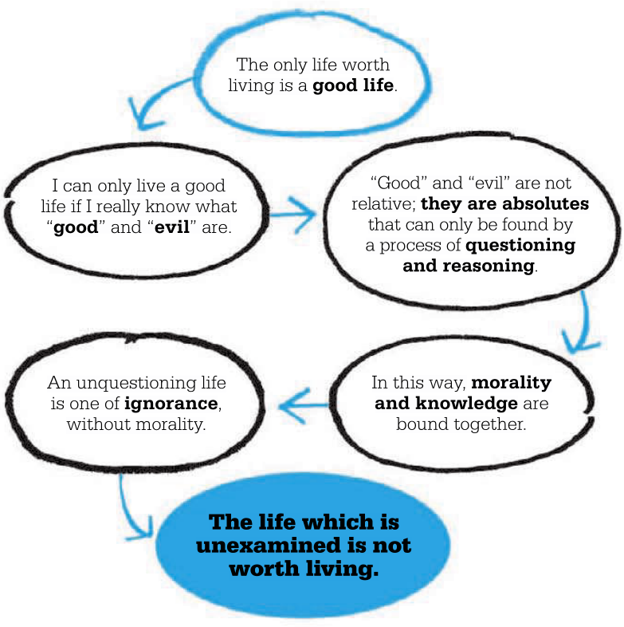
BASIC CONCEPTS OF SOCRATES’S THOUGHT
Socrates’s Ontology: Dualist Idealism
a. There is a second, higher “level” of reality beyond our material (physical) realm.
b. This higher world is an “Ideal” realm of “Spirit.” Our eternal souls belong to it.
Epistemology: Skeptical Rationalism
a. it is impossible for us to have certain knowledge in this life.
b. The only way to pursue better knowledge is through logical questioning.
Ethics: Moral Objectivism (a.k.a. Moral Realism)
a. Right and wrong are objective facts, true for all, which we must discover.
b. Moral Relativism, which says right and wrong are “perspectives,” is false.
-For Socrates, ontology and epistemology are just tools for helping us get closer to ethical truths so we can learn how to live good lives as good people. This is called Virtue (arête) as it is in Daoism (te) and Buddhism (where “virtue” consists of compassionate speech, action, and work, all of which are parts of the Eightfold Path).
-Socrates’s belief is summed up in his epistemological motto, “Know thyself.” Ontological self-knowledge is a path to learning how to “take care of thyself” and cultivate a virtuous soul. This means we have a responsibility to understand who we “truly are,” so that searching for “capital-T” Truth becomes the ultimate value in life.
-At the same time, Socrates does not think we can ever reach Truth. What we can do is get rid of falsehood. This is the point of Socratic Method, or “dialectic,” which is like the cross-examination of a witness in a trial, except that it focuses on concepts. Socrates’s favorite question was, “What is Justice?” The next page gives a summary of his argument on justice.
-Usually Plato’s dialogues end in an unanswered or unanswerable question. This final state was called an “aporia” in Ancient Greek (literally, an “impasse”). It is a point where our concepts or terms fail us, and we realize Truth is beyond our grasp. (Interestingly, this same “aporetic” state is celebrated as the attitude of wu wei, nonattachment, in Daoism. Since “the Dao that can be spoken is not the true Dao,” there are no ultimate truths except wordless Nature itself).
-The other way to react to unanswerable and unsolvable questions is to say everything is a matter of perspective, and there is no capital-T “Absolute Truth,” only “relative” truth (as in, “everything is relative”). This is the path taken by Socrates’s rivals, the Sophists. To overcome them, Socrates finally moves beyond uncertainty and proposes his famous theory of Justice.
From Sparknotes on Plato’s Republic: Summary of Book I
In The Republic, Plato, speaking through his teacher Socrates, sets out to answer two questions. What is justice? Why should we be just? Book I sets up these challenges. The [speakers] engage in a Socratic dialogue similar to that found in Plato’s earlier works. While among a group of both friends and enemies, Socrates poses the question, “What is justice?” He proceeds to refute every suggestion offered, showing how each harbors hidden contradictions. Yet he offers no definition of his own, and the discussion ends in aporia—a deadlock, where no further progress is possible and the participants feel less sure of their beliefs than they had at the start of the conversation. In Plato’s early dialogues, aporia usually spells the end. The Republic moves beyond this deadlock. Nine more books follow, and Socrates develops a rich and complex theory of justice.
Traditionally, the Greek conception of justice came from poets like Hesiod, who in Works and Days presents justice as a certain set of acts that must be followed. The reason for being just, as presented by the traditional view, was consideration of reward and punishment: Zeus rewards those who are good and punishes those who are bad. In late fifth century Athens, this conception of divine reward and retribution had lost credibility. No one believed that the gods rewarded the just and punished the unjust. People could see that many unjust men flourished, and many of the just were left behind. In the sophisticated democracy that evolved in Athens, few were inclined to focus their hopes on the afterlife. Justice became a matter of great controversy.
Leading the controversy were the Sophists, the general educators hired as tutors to the sons of the wealthy. The Sophists tended not to believe in objective truth, or objective standards of right and wrong. They regarded law and morality as conventions. The Sophist Antiphon, for example, openly declared that we ought to be unjust when being unjust is to our advantage. [Against this], Socrates [wanted to] prove that justice is something good and desirable, that it is more than convention, that it is connected to objective standards of morality, and that it is always in our interest to adhere to it.
Book I [sets up a] discussion [between Socrates and a group of citizens] which quickly turns to the subject of justice. Cephalus, a rich, well-respected elder of the city, and host to the group, is the first to offer a definition of justice. Cephalus acts as spokesman for the Greek tradition. His definition of justice is an attempt to articulate the basic Hesiodic conception: that justice means living up to your legal obligations and being honest. Socrates defeats this formulation with a counterexample: returning a weapon to a madman. You owe the madman his weapon in some sense if it belongs to him legally, and yet this would be an unjust act, since it would jeopardize the lives of others. So it cannot be the case that justice is nothing more than honoring legal obligations and being honest.
At this point, Cephalus’s [son] takes over the argument for him. He lays out a new definition of justice: justice means that you owe friends help, and you owe enemies harm. Socrates reveals many inconsistencies in this [version of the definition]. He points out that, because our judgment concerning friends and enemies is fallible, this credo will lead us to harm the good and help the bad. We are not always friends with the most virtuous individuals, nor are our enemies always the scum of society. Socrates points out that there is some incoherence in the idea of harming people through justice. [Still, he agrees with] the underlying imperative of rendering to each what is due and of giving to each what is appropriate.
All this serves as an introduction to Thrasymachus, the Sophist. We have seen, through Socrates’s cross-examination of Polemarchus and Cephalus, that the popular thinking on justice is unsatisfactory. Thrasymachus shows us the nefarious result of this confusion: the Sophist’s campaign to do away with justice, and all moral standards, entirely. Thrasymachus, breaking angrily into the discussion, declares that he has a better definition of justice to offer. Justice, he says, is nothing more than the advantage of the stronger. Though Thrasymachus claims that this is his definition, it is not really meant as a definition of justice as much as it is a de-legitimization of justice. He is saying that it does not pay to be just. Just behavior works to the advantage of other people, not to the person who behaves justly. Thrasymachus assumes here that justice is the unnatural restraint on our natural desire to have more. Justice is a convention imposed on us, and it does not benefit us to adhere to it. The rational thing to do is ignore justice entirely. ( For as long as there has been ethical thought, there have been immoralists like Thrasymachus, people who think that it is better to look out for your own interest than to follow rules of right and wrong. The most famous in modern times was Friedrich Nietzsche).
The burden of the discussion has shifted: now justice must be defined and proven to be worthwhile. Socrates has three arguments to employ against Thrasymachus’ claim. First, he makes Thrasymachus admit that the view he is advancing promotes injustice as a virtue. In this view, life is seen as a continual competition to get more (more money, more power, etc.), and whoever is most successful in the competition has the greatest virtue. Socrates then launches into a long and complex chain of reasoning which leads him to conclude that injustice cannot be a virtue because it is contrary to wisdom, which is a virtue. Injustice is contrary to wisdom because the wise man, the man who is skilled in some art, never seeks to beat out those who possess the same art. The mathematician, for instance, is not in competition with other mathematicians.
Socrates then moves on to a new argument. Understanding justice now as the adherence to certain rules which enable a group to act in common, Socrates points out that in order to reach any of the goals Thrasymachus earlier praised as desirable one needs to be at least moderately just in the sense of adhering to this set of rules. Finally, he argues that since it was agreed that justice is a virtue of the soul, and virtue of the soul means health of the soul, justice is desirable because it means health of the soul.
Thus ends Book I. Socrates and his interlocutors are no closer to a consensus on the definition of justice, and Socrates has only advanced weak arguments in favor of justice’s worth. But the terms of our challenge are set. Popular, traditional thinking on justice is in shambles and we need to start fresh in order to defeat the creeping moral skepticism of the Sophists. [Socrates spends the rest of The Republic arguing for his own conception of Justice as] the principle of specialization, the law that all do the job to which they are best suited. It is based on the imperative of rendering what is due, or giving to each what is appropriate. [In politics, this means that] each person is ideally assigned the role in society that best suits their nature and that best serves society as a whole.
[He argues for a city with three classes]: the truth-loving Philosopher-Kings rule, with the honor-loving Soldiers acting as their helpers to keep the money-loving Crafstmen in line.
Justice in the individual, as in the city, involves the correct power relationship among parts, with each part occupying its appropriate role. In the individual, the “parts” are not classes of society; instead, they are aspects of the soul—or sources of desire. In order to make the case that individual justice parallels political justice, Socrates must claim that there are precisely three parts of the soul. By cataloging the various human desires, he identifies a rational part of the soul that lusts after truth, a spirited part of the soul that lusts after honor, and an appetitive part of the soul that lusts after everything else, including food, drink, sex, and especially money. These three parts of the soul correspond to the three classes in the just city. The appetite, or money-loving part, is the aspect of the soul most prominent among the producing class; the spirit or honor-loving part is most prominent among the auxiliaries; and reason, or the knowledge-loving part, is dominant in the guardians.
Just relations between the three parts of the soul mirror just relations among the classes of society. In a just person the rational part of the soul rules the other parts, with the spirited part acting as helper to keep the appetitive in line. What it means for one part of the soul to “rule” the others is for the entire soul to pursue the desires of that part. In a soul ruled by spirit, for instance, the entire soul aims at achieving honor. In a soul ruled by appetite, the entire soul aims at fulfilling these appetites, whether these be for food, drink, sex, fine material goods, or hordes of wealth. In a just soul, the soul is geared entirely toward fulfilling whatever knowledge-loving desires reason produces.

